**Sprint 3 Plan**

**Heading**:

Product Name: BeatBox

Sprint Completion Date: July 23rd, 2023

Revision Number: 1

Revision Date: July 16th, 2023

**Goal:** To allow the user to use a solo button to isolate a channel, add 8 total channels to the app, and then allow users to enter their information, log in and access their most recent 10 saved snapshots.

**Task Listing and Initial Assignments:**

**1. 8 Channels**: As a musician, I want to use up to 8 instrument channels so I can make more complex rhythms. (Priority: High) (Story Points: 5)

**Acceptance Criteria:**

1. All 8 channels should play/stop at the same time
2. All 8 channels must be included in recordings
3. All 8 channels have independent controls (volume, panning, instrument soundbyte, mute) that do not interfere with each other

**Tasks:**

1. Give all instrument channels unique IDs (0 hrs)
2. Keep all 8 channels in-sync. Refactor code to set up loops / arrays / copying and pasting to include all 8 channels (6 hrs)

**2. Solo Button**: As a musician, I want to solo certain sounds so that I can see how one specific channel sounds clearly. (Priority: Medium) (Story Points: 5)

**Acceptance Criteria:**

1. Mutes all other instruments
2. Unmutes the instrument playing if it is muted
3. Make the solo button light up on the playing instrument to to indicate it is active
4. Save mute status of all instruments before soloing and restore those mutes afterwards
5. Allow user to switch between soloing different instruments without actively disabling soloing on a previous instrument

**Tasks:**

1. (UI Setup) Solo button can be clicked and toggled on (red-colored) or off (gray-colored) to enable or disable solo instrument channel playback, default setting is toggled off (2 hrs)
2. There can only be one active solo button at a time: if an instrument’s solo button is enabled, all other instrument solo buttons will be disabled, when an instrument’s solo button is pressed, all other unmuted instruments will have their mute button toggled on (4 hrs)
3. If an instrument’s mute button is toggled on and then that instrument’s solo button gets pressed, the instrument’s mute button will be toggled off; if an instrument’s solo button is toggled on and then toggled off, all instruments that were muted by toggling the solo button will be unmuted (4 hrs)

**3. Snapshot Download**: As a musician, I want to download a “snapshot” of my drum pattern that I can re-upload and continue editing later so I can make quick and easy changes. (Priority: High) (Story Points: 13)

**Acceptance Criteria:**

1. Be able to download a file containing all the session’s settings
2. Be able to upload a file with saved presets ( and restore the previous session)
3. Have a popup error if the file cannot be successfully loaded
   1. Do not overwrite the current session if the load fails

**Tasks:**

1. Setup save and load (download and upload) buttons in top right (2 hrs)
2. Set up system to download and upload all file as a .zip file (folder) (4 hrs)
3. Make a class to store key values (8 hrs)
   1. Instrument specific values: volume, panning, etc. (2 hrs)
   2. Also stores note grid (boolean 2D array), tempo (4 hrs)
   3. Sound sources (included in the .zip) (2 hrs)
   4. Note: store all values only when the download button is hit, not as the values are inputted
   5. Note: probably storing in a JSON file

**4. Panning Knob**: As a musician, I want to change the panning of certain sounds so I can use spatial positioning to make the soundstage more immersive. (Priority: High) (Story Points: 5)

**Tasks:**

1. Add a Panning Knob to the purple instrument channel. Clicking the Panning Knob and dragging changes the panning amount from -100 to 100. (2 hours)
2. Mousing over the Panning Knob displays the current panning amount. (1 hour)
3. Double-clicking the Panning Knob resets the panning back to 0. (2 hours)

**Team Roles:**

**Product Owner**: Dakota Rubin

**Scrum Master**: Andrew Yniguez, Victor Maher

**Team**: Andrew Yniguez, Clarissa Sepulveda, Dakota Rubin, Jose Patino, Victor Maher, Victoria Moore

**Initial Burnup Chart:**

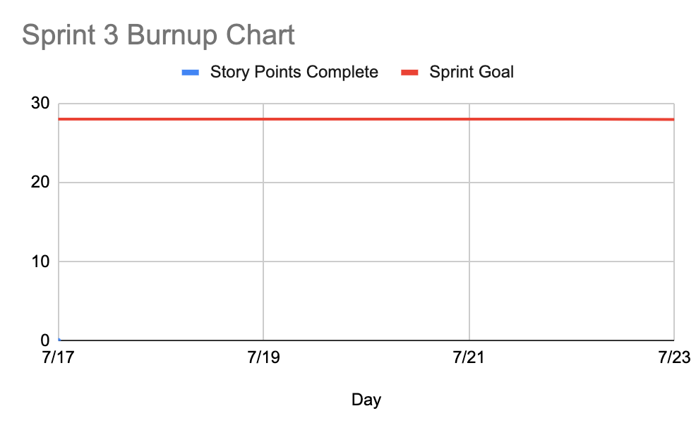

**Initial Scrum Board:**

Hosted on Trello: https://trello.com/b/alEVMUhs/agile-task-board

**Scrum Times:**

1. Monday July 17th @ 1:30 PM (in-person)
2. Tuesday 3:00 PM (online)
3. Wednesday 1:30 PM (in-person)
4. Friday 6:00 PM (online)